УДК: 37.022:355.231(477)

Добіжа Н.В. Використання комп’ютерної програми-тренажеру в процесі навчання іноземної мови / Н.В. Добіжа // Інформаційні технології в освіті. – Електороний журнал. – Харків, 2018. – № 2 (35). – Режим доступу: http://ite.kspu.edu/en/Issue_35/p-89-99
ISSN 1998-6939 (Online)

Автор
Добіжа, Н.В.
Добижа, Н.В.
Dobizha N.V.
Назва
Використання комп’ютерної програми-тренажеру в процесі навчання іноземної мови.
Использование компьютерной программы-тренажера в процессе обучения иностранному языку.
The Use of Computer Training Program in the Foreign Language Classroom.

Ключові слова
Ключові слова: урок іноземної мови, комунікація, технічні засоби, позитивно-активне ставлення, рефлексивні навички.
Ключевые слова: урок иностранного языка, коммуникация, технические средства, позитивно-активное отношение, рефлексивные навыки.
Key words: the lesson of a foreign language, communication, digital tools, positively-active attitude, reflective skills.

Анотації
Стаття присвячена проблемі використання інформаційно-комунікативних технологій у процесі навчання іноземної мови. Розроблена нами програма-тренажер для навчання іноземної мови орієнтована насамперед на організацію взаємодії між викладачем та студентами. В основі нашої розробки лежить ідея конструктивістської педагогіки, яка прагне створити для студентів розвивальне середовище, що забезпечує можливості пошуку власного Я, навчити способам конструювання знань, виходячи з індивідуальності і неповторного досвіду кожної особистості. При створенні програми-тренажеру ми використовували програми Exсel та Moodle (модульне об'єктно-орієнтоване динамічне навчальне середовище, яке може використовуватися, як платформа для електронного, в тому числі дистанційного навчання). Опис використання програми-тренажеру передбачає аналіз різних аспектів уроку іноземної мови та спирається на практичний досвід роботи викладача іноземної мови з групою та реалізацію принципу індивідуального підходу у навчанні. У статті здійснено обґрунтування використання навчальної комп’ютерної програми, що сприяє гармонійній соціальній та психологічній взаємодії між викладачем та його учнями та допомагає здійснити вибір завдань залежно від рівня кожного учасника групи. Модульне об'єктно-орієнтоване динамічне навчальне середовище може використовуватися як платформа для електронного, в тому числі дистанційного навчання. Розроблена нами програма реалізує філософію «педагогіки соціального конструктивізму» та орієнтована насамперед на організацію взаємодії між викладачем та студентами.

Статья посвящена проблеме использования информационно-коммуникативных технологий в процессе обучения иностранному языку. Разработанная нами программа-тренажер для обучения иностранному языку ориентирована прежде всего на организацию взаимодействия между преподавателем и студентами. В основе нашей разработки лежит идея конструктивистской педагогики, стремится создать для студентов развивающую среду, что обеспечивает возможности поиска собственного Я, научить способам конструирования знаний, исходя из индивидуальности и неповторимого опыта каждой личности. При создании программы-тренажера мы использовали программы Exсel и Moodle (модульная объектно-ориентированное динамическое учебную среду, которое может использоваться как платформа для электронного, в том числе дистанционного обучения). Описание использования программы-тренажера предусматривает анализ различных аспектов урока иностранного языка и опирается на практический опыт работы преподавателя иностранного языка с группой и реализацию принципа индивидуального подхода в обучении. В статье осуществлено обоснование использования учебной компьютерной программы, способствует гармоничной социальной и психологической взаимодействия между преподавателем и его учениками и помогает осуществить выбор задач в зависимости от уровня каждого участника группы. Модульное объектно-ориентированное динамическое учебная среда может использоваться как платформа для электронного, в том числе дистанционного обучения. Разработанная нами программа реализует философию «педагогики социального конструктивизма» и ориентирована прежде всего на организацию взаимодействия между преподавателем и студентами.

Тhe article is devoted to the problem of information and communication technologies usage in the foreign language classroom. There offered some practical recommendations of students' pedagogical support provided through the computer training program.
The article responds to call for principles and teaching practices that address the worldwide problem of various aspects of a foreign language lesson. It draws on educational research and extensive experience with classroom practices to explain important principles for combining the process of speaking teaching, listening skills’ training and grammar practice. In contrast to other subjects the lesson of a foreign language should develop the understanding of languages and cultures through various experiences, fostering a positive attitude toward communication. For this reason, we should follow the individual approach in teaching English.
According to this goal we suggest that usage of a training program helps providing harmonious social and psychological interaction between the teacher and his students, choosing the tasks according to the level of each student, organizing various activities in the foreign language classroom, carrying out objective control over the students’ progress.
Key words: the lesson of a foreign language, communication, digital tools, positively-active attitude, reflective skills.

1. INTRODUCTION
The problem setting.
An important specific feature of a foreign language lesson is a variety of activities: speaking, writing, listening etc.
Within a short period of time a teacher should not only solve purely educational tasks: explain a new material, assign the tasks to students, monitor their implementation, and correct mistakes, but also involve all the students with different levels and capabilities to the process of practicing a foreign language. At the same time the specifics of a foreign language lesson require teaching through communication.
And communicative skills in general are one of the basic requirements in the modern social environment and information space.
The materials of the World Program for Human Rights Education 2012 of the United Nations point out that the integration processes in the development of the theory and practice of foreign language teaching in Europe should be developed on the basis of the principles of subjective orientation, continuity, cultural compatibility, variability.
The Council of Europe has offered the linguistic and pedagogical principles for the European languages teaching in the context of communicative-oriented approach. Implementation of this approach predicts the preserving and enrichment of the linguistic and cultural heritage during the age of intensive exchange of scientific and technical information. The decisive principle of this approach is the orientation towards language learning as a means of communication in real life situations, relevant for students, and not for teachers and authors of the textbooks.
Integration into the European educational space make us pay our attention to the problem of foreign language teaching as a process of continuous interaction when a teaching and communicative aspect are closely connected in order to create necessary conditions for an authentic, foreign language teaching influence. It deals with reformation of European national education in order to prepare the individuals of innovative type, when the socio-psychological interaction is especially important. Besides, there is a lack of adequate research on the problem. What methods can provide this process of identity, originality, uniqueness of communication during the English lesson? What steps can be made to teach children speaking, reading, listening comprehension and writing on the same level? How can be provided an effective socio-psychological interaction between the teacher and students? In our article we’ll try to find the answers to these questions.
According to the latest studies of foreign philosophers Y. Habermas, K. Apel, K. Jaspers the rapid development of the information society contributes to the nascence of a new communicative philosophy. In our research we consider the ability to communicate effectively with the help of informative technologies as a demand of a modern communicative society and determine it as the “21st century’s skills” [4; 5].
In these conditions we should implement the principle of communicative approach through modern technologies while teaching a foreign language. Besides, the materials of the World Program for Human Rights in the sphere of Education by 2012 of the United Nations state that the theory and practice of foreign language teaching in Europe should become an integrated process developed on the basis of the principles of subjective orientation, continuity, cultural compatibility and variability [7, p. 23 - 24]. A teacher of a foreign language should have a high professional competence, which implies not only deep knowledge and erudition, but also a non-standard thinking to implement methods of creative tasks solving.
The globalization of economics and informatization of society have new challenges. One should be not disciplined but creative, not standard but tolerant, not obedient but flexible. Such a phenomenon as "a man of the masses", which involves a unified style of thinking and behavior, can’t be effective for teachers any more.
Therefore, it is particularly important to train highly professional pedagogical workers who meet the integration criterion "professional skills = the art of communication + new technologies". Only then we can bring in correspondence the goals, wishes and peculiarities of a certain individual to the real goals and objectives of the modern society.
The analysis of recent studies and publications. The problems of effective organization of a foreign language practice have been studied by many modern scholars: S. Brookfield, S. Dalton, D. Carlán, S. Filuf and others. Most of them have a similar point of view to the necessity of student's support in the process of teaching when [10, p. 112-113]. The questions of individualization and humanization of a foreign language teaching have been studied by German scientists K. Aichhorn, E. Heimlich, E. Royber. The scientists suggest that students should be able to monitor their own activities while practicing a foreign language. Unfortunately very few teachers organize the process of practicing when students can reflect and realize their progress or its absence.
German scientists – G. Bove and S. Dalton – write about the importance of individual tasks for each student according to his individual level and abilities [2].
The basic principles of an effective communication in a foreign language have been studied by many scientists. According to the views of N. Bidikova it involves being a good interlocutor, understanding and perception of other people’s speech, respect for others, equality of psychological positions; penetration into the world of feelings and experiences, readiness to accept the interlocutor’s position, non-standard methods of communication [7, p. 58].
The studies of such modern American educators as P. Hall, A. Simeral, J. Pfeffer and R. Sutton are of great importance for our investigation, because they clearly define the difference between a usual and reflexive lesson and determine communicative aspect as the main feature of interaction in a foreign language lesson [10].
Such researchers as O. Kovalenko, S. Nikolaev, T. Polyakova, M. Skuratovskaya, F. Hass, E. Horvits, C. Freys and others analyze methodological features of a foreign language lesson. Summarizing their studies we can determine the following main characteristics of a foreign language lesson: the substantive content of speech and emotional attitude towards it; variety of activities (speaking, reading, listening, writing); integrity, dynamics and coherency of the lesson; emotional comfort; functional correspondence of the elements of native and foreign languages; equal semantic saturation of these elements [7; 10].

2.RESEARCH METHODS
Theoretical methods have been used, namely: analysis and synthesis of pedagogy literature; the method of mathematical statistics for interpretation of research results; the practical approach involving the firsthand research in the form of social experiment.
3. THE RESULTS AND DISCUSSION
In our research we would like to offer some digital tools in order to implement all the mentioned approaches in practice and to make the lesson’s organization more effective.
Herewith the teacher plays the role of a psychotherapist, whose aim is to help students discover their internal reserves and use them without feeling uncomfortable, constrained or defective. It deals with a facilitating function of a learning process at a foreign language lesson.
We have worked out a computer training program “Steps for Success” on the basis of Exel and Moodle programs. We have also used the materials of the worldwide known programs: “English Live”, “Exceller”, “Side by side” and “Transparent language”.
It’s an accompanying means of teaching which can be used at different stages of a lesson according to its goals, content, and students’ level. In no case it can’t replace a blackboard and chalk or speaking practice with a native speaker. But it has its benefits in comparison to an ordinary lesson.
For example, the program “Steps for Success” for the lower intermediate B1 class in English includes the system of theoretical, practical tasks, exercises, instructions, advice, videos, presentations, records, games and grammar tests (P.1).

P.1.
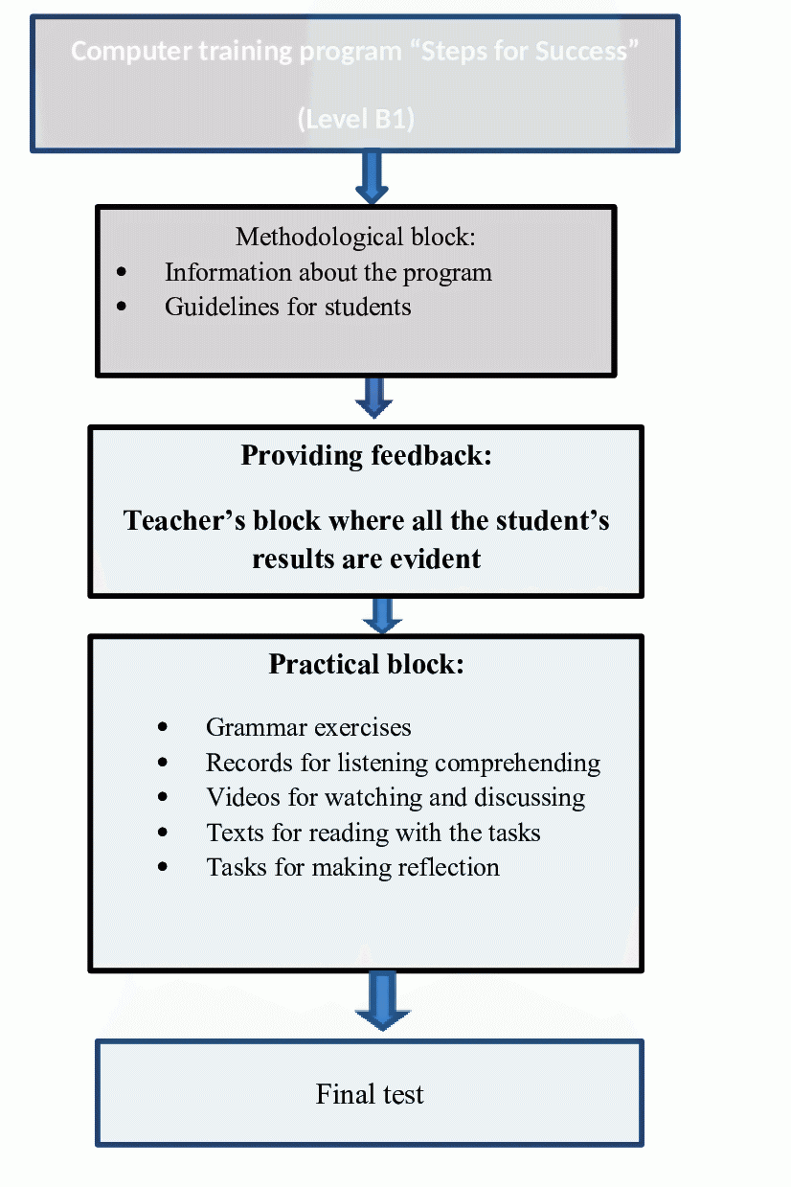
The use of such a program has a list of advantages.
1. Showing a positively-active attitude towards students.
For example, when a student shows a lack of interest in a foreign language course, a teacher can motivate him suggesting a block of a program which is close to him. In such situations, the teacher’s reaction can be the following:
"But you like to play computer games, don’t you? Do you know that English will greatly expand your capabilities? You can communicate with the players from all over the world and it can be much more interesting. Besides you could practice doing it just now. You could chose one of the educational games and just try"
"Do you think you do not need English?" You dream to travel around the world. How will you feel when you cannot express elementary things in a foreign country? You could watch some videos using the program “Steps for Success". There are very useful Blocks – asking for directions, in a hotel, at the airport – even with subtitles”
"I heard that you were constantly listening to English songs during the breaks. Don’t you want to know what they are about? Let's listen to one of your favorite songs together!"
The main aim is to ensure the relationship between teacher and students, psychological involvement of students into the problem being discussed.
2. Following the principle “Step by step”.
One of the main problems of studying a foreign language in a group is that the students proceed differently: someone makes progress quickly, someone needs more time to succeed, someone is good at speaking, but has weak writing or listening skills and vice versa. The computer program makes it possible to train certain skills of each student at the same time. Besides, grammar and listening tasks must be completed on the basis of the taxonomy of goals proposed by B. Bloom and R. Mortzano: learning theoretical rules – comprehending – applying – analyzing – evaluating. If a student makes mistakes while building sentences with a certain construction, he can always come back to the level of theoretical rules or practicing tests (App. 1).
3. Intuitive process of learning.
The program “Steps for Success” helps organize the learning process in such a way when students trust their own instincts and intuition. The program is just guidance as to what to do next, encourages students and shows what need to be exercised and developed.
Students can even not realize that they are learning a foreign language. It deals with active involvement, learning by doing, using language to structure their concepts.
We can support this process of learning by providing activities with simple repetitive lines in each lesson [6]. Another way in which students are encouraged to produce language is through songs, rhymes and tongue twisters. Listening activities play an important part in the language classroom as they provide an opportunity for students to articulate the new language within a melodic framework (App. 2).
4. Improving students’ listening skills.
To make communication more available for students, it is obvious that they shouldn’t have any barriers during the perception of a foreign language material.
Students (at primary and high school) need the minimum necessary knowledge of the so-called pedagogical phonetics1 (or "student phonetics"). It’s a component of the so-called general linguistic awareness, which involves students’ mastering all the sounds of a foreign language, rhythm and basic intonation models, common types of simple and complex sentences.
It’s important to remember, that according to the European Recommendations on Language Education, one of the main principles of teaching the pronunciation is the principle of approximation, when phonetic errors are not taken into account, if there is achieved the main purpose of communication – general understanding.
In order to form a phonetic competence during the phonetic fragments of the lessons there can be used a variety of teaching methods. The program “Steps for Success” includes phonograms and video recordings with samples of authentic speech are of major importance. These are the records of poems, rhymes, songs, dialogues, special phonetic exercises for listening and imitation, as well as fragments of films, TV programs, etc. When the students of one group have different levels of English they can listen to a record or watch a video using head phones, and then complete the tasks. If the level of students doesn’t differ greatly they can listen to the records or watch video all together and there can be organized a group discussion (App. 3).
- Developing students’ reflective skills.
If we talk about the problems of communication, we should say about the problems of each person separately. And if we talk about the problems of each individual, we should take into account his ability to reflect to the changes of communicative situations and to react in a proper way.
The basic principle of an effective communication is its interactive feature. It involves being a good interlocutor, understanding and perception of other people, respect for others, equality of psychological positions; penetration into the world of feelings and experiences, readiness to accept the interlocutor’s position, non-standard methods of communication [7, p. 458]. It deals with people’s ability to reflect as an important condition of effective communication within a modern society.

Reflective abilities development is based on the idea of ​​a fundamental difference between standard ("routine") and reflective personality. The main principle of communication in the foreign language classroom should be based on the theory of integral individuality offered by V.S. Merlin, in particular his compensatory mechanism theory [1]. According to this concept, we can mention three main aspects of their implementation in practice:
• problematic communicative situations;
• research approach in solving educational problems;
• reliance on the positive aspects of each individual.
Methodological tools used during the training are the following: group discussion (if it’s organized within a group), analysis of situations, role play, instruction, keeping diaries. Group discussion is much more preferable. What is discussed in a group is much more transparent and clearer.
Students should have an opportunity to analyze how they proceed; what encourages them to improve themselves, what would they change to become a successful speaker? If necessary this problems can be discussed in a native language. The main aim of the task is to determine how to make the process of a foreign language learning easier and more interesting.
After every lesson, it is advisable for teachers to give a recap or to ask a student to give one. Doing recaps helps the students consolidate everything they have learned for the past hour or more into their heads. Don’t ask only about the learned material, but also about the students’ impressions, problems in communication and understanding. It’s quite important to know what your students would like to change in order to make the communicative process in the foreign language classroom not only instructive, but also interesting and less formal. Also it may help teachers to realize whether students sometimes underestimate or overestimate their language ability (App.4).
We have conducted an educational experiment involving 402 Ukrainian students who have been learning English as a second language already for 9-10 years. They were divided into two groups: control (200) and experimental (202). The level of an average student at this age must correspond to B1 (the international standard in measuring language ability). We’ve conducted a group of tests in English in order to measure an objective and reliable evidence of English language ability in both groups.
According to the results we are going to use the following classification of levels for the diagnostics of English level: high (corresponds to B1), pre-advanced, intermediate and low.
To test the hypothesis of equality of data, we applied the t-statistic. We took into account that the level of significance is a measure of statistical reliability of the result of calculations. If the study shows that the p-value is below the threshold chosen for statistical significance (usually the 0.10, the 0.05, or 0.01 level), then the null hypothesis is rejected in favor of the alternative hypothesis [1].
The results of diagnostics were the following.
Table 1
 | Scores (%)
Group | High | Pre-advanced | Intermediate | Low
Control | 3,9 | 14,6 | 35,2 | 46,3
Experimental | 3,6 | 14,7 | 36 | 45,7

It can be stated that the level of English language ability is almost equal in the control and experimental groups before the beginning of the experiment, with a significance level of 0.05.
The experimental group of students was to work with the computer program “Steps for Success” during the period of 5 months. The control group was to have ordinary lessons according to the school program.
At the end of the experiment we have examined the level of English language ability in the control and experimental groups.
The results of diagnostics were the following.
Table 2
 | Scores (%)
Group | High | Pre-advanced | Intermediate | Low
Control | 3,9 | 15,8 | 35 | 45,3
Experimental | 8 | 19,4 | 40,7 | 31,9
Herewith p ≤ 0.05, which confirms the reliability of the data.
According to the results of the table the level of English has essentially increased in the experimental group.

Experimental group Control group
Figure 3.Diagramm
4. Conclusions and prospects for further research
We can draw the conclusion that the teaching process in the foreign language classroom should be bright, attractive and cause the interest of the participants of the educational process. Taking into account complicated mechanisms of a foreign language teaching process, we should search for opportunities for its facilitating and efficiency improvement.
We should look for methods which can help students develop their motivational sphere, values, meanings, goals of educational activity; increase their readiness for innovations, creative search; awareness of educational tasks, individual mental qualities; strengthen the needs and abilities in a positive self-concept building; form the need and ability of individual expression in communication.
Use of digital tools the teaching process in the foreign language classroom corresponds to the principle of integrity of theory and practice, calls for intuitive learning of a foreign language. But we shouldn’t forget that teachers should be well prepared for such a kind of work with students. First of all they should be digitally competent and flexible.

References:
- Добіжа Н.В. Формування індивідуального стилю педагогічного спілкування майбутніх учителів іноземної мови в процесі педагогічної практики:. дис. ... канд. пед. наук : 13.00.04 / Н. В. Добіжа ; Вінниц. держ. пед. ун-т ім. М. Коцюбинського. – Вінниця, 2016. – 298 с.
- Ноженкина О. С. Роль рефлексии в преодолении профессиональной деформации личности педагога / О. С. Ноженкина. – Смоленск, 2012. – 222 с.
- Соковин В. М. Фасцинация. Коммуникация. Общение: сб. ст. / под ред.
- В. М. Соковнина. – Екатеринбург, 2010. – 134 с.
- Лосев А .Ф. Форма. Стиль. Выражение / А.Ф. Лосев. – Москва. – Изд-во "Мысль", 1995. – 940 с.
- Hass F. Fachdidaktik Englisch. Tradition - Innovation - Praxis / Frank Hass. – Ernst Klett Sprachen GmbH. – Stuttgart, 2006. – 336 S.
- Jansen F. Lesen und Rechtschreiben lernen nach dem IntraActPlus-Konzept: Vollständig individualisiertes Lernen in Klasse 1 und 2 / Fritz Jansen, Uta Streit, Angelika Fucks // Frühförderung, Kindergarten und Vorschule. Verhindert und therapiert Legasthenie Loseblattsammlung. – Springer Verlag. – Heidelberg, 2012. – 213 S.
- Nilson L. B. Creating Self-Regulated Learners: Strategies to Strengthen Students' Self-Awareness and Learning Skills Instructors / Linda B. Nilson. – Jossey-Bass Publishers. – San Franciscо, 2013. – 145 p.
- Локк Дж. Два трактати про правлыння / Дж. Локк. – Твори в 3 т. М.: Думка, 1988. – Т. 3. – С. 460-461.

Shigehiro Oishi. The Psychological Wealth of Nations: Do Happy People Make a Happy Society / Oish Shigehiro // Publisher: Wiley-Blackwell, 2012. – 260 p.
- Wunsch A. Mit mehr Selbst zum stabilen ICH!: Resilienz als Basis der Persönlichkeitsbildung / Albert Wunsch. – SpringerSpektrum, 2013. – 336 S
- Hall P. Teach, Reflect, Learn: Building Your Capacity For Success In The Classroom Availability / Pete Hall, Alisa Simeral. – ASCD. – Alexandria, Virginia. – USA, 2015. – 177 p.
- Howes R. PhD, ABPP In Therapy / Ryan Howes. – 8 More Reasons to Go to Therapy. – Mode of eccess: https://www.psychologytoday.com/blog/in-therapy/201403/8-more-reasons-go-therapy
- Henriques G., Ph.D. /Gregg Henriques. – Self-Reflective Awareness: A Crucial Life Skill. – Psychology today. – Sept. – 2016. Mode of access: https://www.psychologytoday.com/blog/theory-knowledge/201609/self-reflective-awareness-crucial-life-skill
- Pfingsten, U. (2008). Training sozialer Kompetenz. In J. Margraf (Hrsg.), Lehrbuch der Verhaltenstherapie. Bd.1: Grundlagen, Diagnostik, Verfahren, Rahmenbedingungen. Berlin: Springer. Author's personal copy Selbstreflexion und soziale Kompetenz 371 Potreck-Rose, F. (2003). Psychotherapeutische Interventionen zur Stärkung des Selbstwertes. Psychotherapie im Dialog, 6(3), 313 – 317.
- Chung, C. K., & Pennebaker, J. W. (2007). The psychological function of function words. In K. Fiedler (Ed.), Social communication: Frontiers of social psychology (pp. 343-359). New York: Psychology Press
- Brookfield S. D. Discussion as a Way of Teaching: Tools and Techniques for Democratic Classrooms / Srephen D. Brookfield. – Jossey-Bass Publishers. – San Francisco, 2005. – 287 p.
- Frankl V. E. Man's Search for Meaning [Electronic Resource] / Viktor E. Frankl (Author), William J. Winslade (Afterword), Harold S. Kushner (Foreword). – Popular Psychology Counseling. – Mode of access: http://www.amazon.com/Mans-Search-Meaning-Viktor-Frankl/dp/080701429X/ref=asap_bc?ie=UTF8

References (TRANSLATED AND TRANSLITERATED)
- Dobizha N.V. Formuvannia indyvidualnoho styliu pedahohichnoho spilkuvannia maibutnikh uchyteliv inozemnoi movy v protsesi pedahohichnoi praktyky:. dys. ... kand. ped. nauk : 13.00.04 / N. V. Dobizha ; Vinnyts. derzh. ped. un-t im. M. Kotsiubynskoho. – Vinnytsia, 2016. – 298 s.
- Nozhenkyna O. S. Rol refleksyy v preodolenyy professyonalnoi deformatsyy lychnosty pedahoha / O. S. Nozhenkyna. – Smolensk, 2012. – 222 s.
- Sokovyn V. M. Fastsynatsyia. Kommunykatsyia. Obshchenye: sb. st. / pod red.
- V. M. Sokovnyna. – Ekaterynburh, 2010. – 134 s.
- Losev A .F. Forma. Styl. Vыrazhenye / A.F. Losev. – Moskva. – Izd-vo "Mysl", 1995. – 940 s.
- Hass F. Fachdidaktik Englisch. Tradition - Innovation - Praxis / Frank Hass. – Ernst Klett Sprachen GmbH. – Stuttgart, 2006. – 336 S.
- Jansen F. Lesen und Rechtschreiben lernen nach dem IntraActPlus-Konzept: Vollständig individualisiertes Lernen in Klasse 1 und 2 / Fritz Jansen, Uta Streit, Angelika Fucks // Frühförderung, Kindergarten und Vorschule. Verhindert und therapiert Legasthenie Loseblattsammlung. – Springer Verlag. – Heidelberg, 2012. – 213 S.
- Nilson L. B. Creating Self-Regulated Learners: Strategies to Strengthen Students' Self-Awareness and Learning Skills Instructors / Linda B. Nilson. – Jossey-Bass Publishers. – San Franciscо, 2013. – 145 p.
- Локк Дж. Два трактати про правлыння / Дж. Локк. – Твори в 3 т. М.: Думка, 1988. – Т. 3. – С. 460-461.

Shigehiro Oishi. The Psychological Wealth of Nations: Do Happy People Make a Happy Society / Oish Shigehiro // Publisher: Wiley-Blackwell, 2012. – 260 p.
- Wunsch A. Mit mehr Selbst zum stabilen ICH!: Resilienz als Basis der Persönlichkeitsbildung / Albert Wunsch. – SpringerSpektrum, 2013. – 336 S
- Hall P. Teach, Reflect, Learn: Building Your Capacity For Success In The Classroom Availability / Pete Hall, Alisa Simeral. – ASCD. – Alexandria, Virginia. – USA, 2015. – 177 p.
- Howes R. PhD, ABPP In Therapy / Ryan Howes. – 8 More Reasons to Go to Therapy. – Mode of eccess: https://www.psychologytoday.com/blog/in-therapy/201403/8-more-reasons-go-therapy
- Henriques G., Ph.D. /Gregg Henriques. – Self-Reflective Awareness: A Crucial Life Skill. – Psychology today. – Sept. – 2016. Mode of access: https://www.psychologytoday.com/blog/theory-knowledge/201609/self-reflective-awareness-crucial-life-skill
- Pfingsten, U. (2008). Training sozialer Kompetenz. In J. Margraf (Hrsg.), Lehrbuch der Verhaltenstherapie. Bd.1: Grundlagen, Diagnostik, Verfahren, Rahmenbedingungen. Berlin: Springer. Author's personal copy Selbstreflexion und soziale Kompetenz 371 Potreck-Rose, F. (2003). Psychotherapeutische Interventionen zur Stärkung des Selbstwertes. Psychotherapie im Dialog, 6(3), 313 – 317.
- Chung, C. K., & Pennebaker, J. W. (2007). The psychological function of function words. In K. Fiedler (Ed.), Social communication: Frontiers of social psychology (pp. 343-359). New York: Psychology Press
- Brookfield S. D. Discussion as a Way of Teaching: Tools and Techniques for Democratic Classrooms / Srephen D. Brookfield. – Jossey-Bass Publishers. – San Francisco, 2005. – 287 p.
- Frankl V. E. Man's Search for Meaning [Electronic Resource] / Viktor E. Frankl (Author), William J. Winslade (Afterword), Harold S. Kushner (Foreword). – Popular Psychology Counseling. – Mode of access: http://www.amazon.com/Mans-Search-Meaning-Viktor-Frankl/dp/080701429X/ref=asap_bc?ie=UTF8

Appendix
App.1.
Screenshot from the program “Steps for Success”
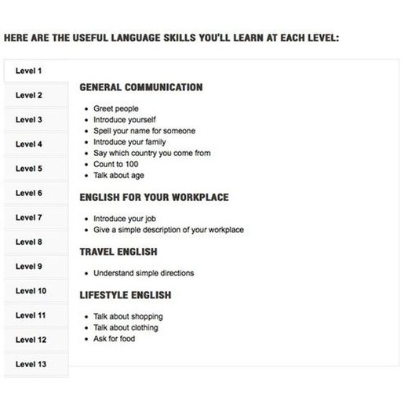

App. 2.
Screenshot from the program “Steps for Success”

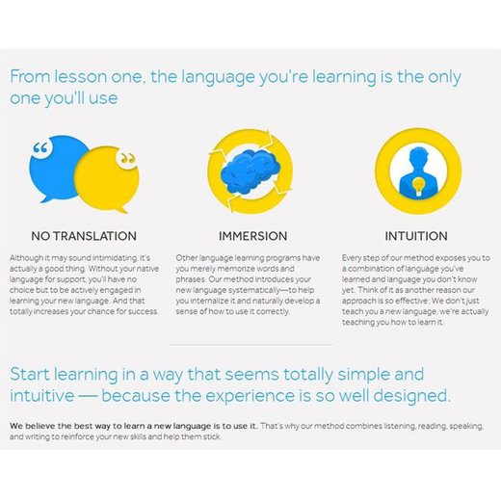

App. 3.
Screenshot from the program “Steps for Success”

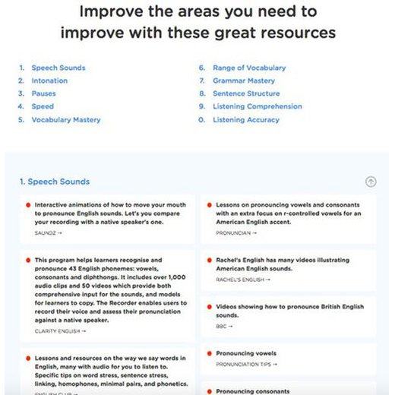
App. 4.
Screenshot from the program “Steps for Success”

